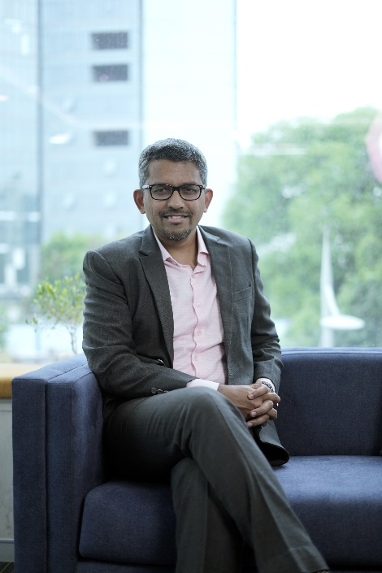

Vineet Sukumar is the Founder and MD of Vivriti Group, that comprises of Vivriti Capital (VC), a fintech NBFC incorporated in 2017, and Vivriti Asset Management (VAM), a registered asset manager of fixed-income alternative investment funds incorporated in 2019.

Vivriti Group – a highly profitable 8+year old venture - was conceptualised with a vision to ensure an inclusive and equitable growth for midmarket enterprises in India. The group caters to the diverse needs of 1000+ mid-market enterprises across 55+ sectors, including but not limited to auto, engineering, renewable energy, healthcare, infrastructure, and financial services. With over US$1.5 billion in assets and a wide range of tailored products and services, Vivriti has built significant expertise and a robust business model through specialized technology, customised products, multi-level underwriting, superior portfolio management, and highly effective distribution.

Vivriti Group is backed by marquee investors - Creation Investments, Lightrock, and TVS Capital, and is recognised as a “Soonicorn” owning to its phenomenal growth and value addition in the BFSI space.

Vineet has 21+ years of experience in financial services and is an industry expert in debt capital markets, performing credit, financial inclusion and asset management. Vineet has completed his education from IIT, Kharagpur, and IIM, Bangalore.

LinkedIn: linkedin.com/in/vineetsukumar

